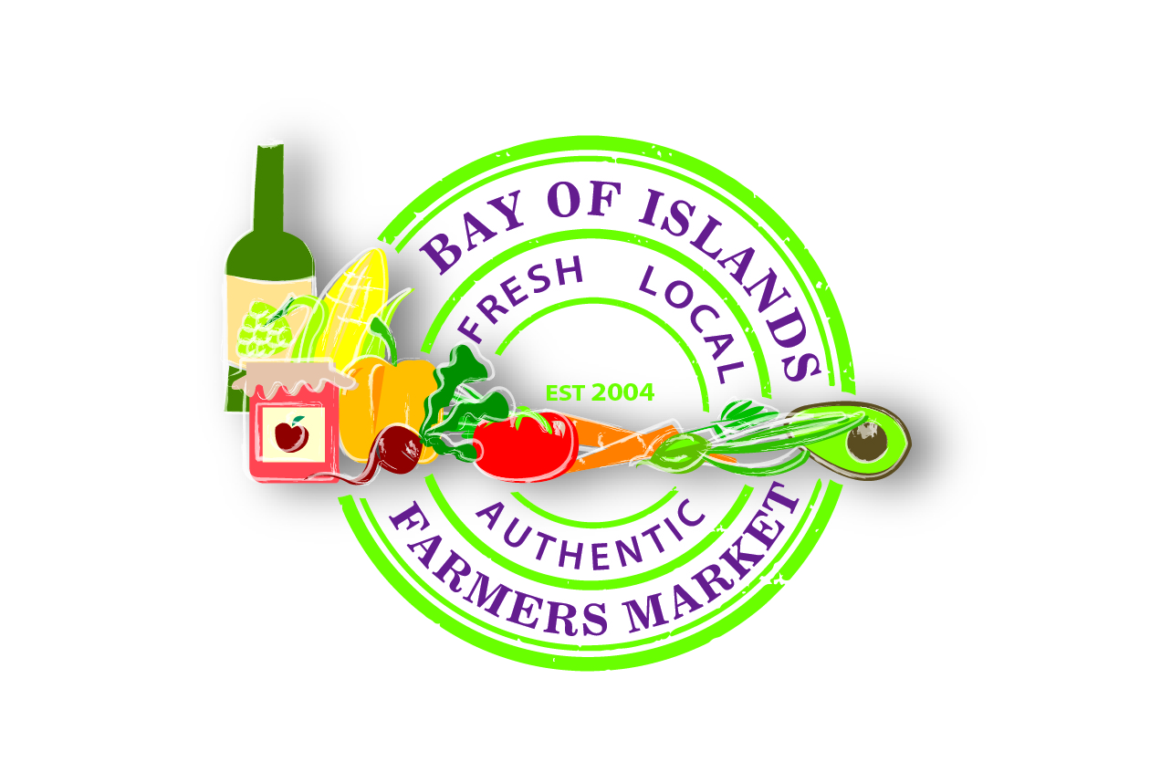
Bay of Islands
FARMERS MARKET
STALLHOLDER CONTRACT Valid from1st April 2017to 31st March 2018

Permanent Stallholder / Seasonal Stallholder (circle one)

I have read, fully understand and accept the rules outlined in the Bay of Islands Food Group Inc. Stallholder Agreement & Constitution.
I understand I only have approval to sell the items on my approval list (available on request) and that if I wish to sell any additional items then these will be the subject of a separate application.
I further declare that all produce/product offered for sale on my stall will be grown or produced by myself in Northland.
(Stallholder)
Signed: .................................................... Date: ......................................... Signed:…………………………………………………..Date: ……………………………………..
Please fill out below in clear writing (if two separate memberships are required please put in both names and both sign.

Name: ................................................................................................................. Name: ............................................................................................................................
Position in Business: ........................................................................................... Position in Business : ……………………………………………………………………………………………………
Business Name: …………………………………………………………………………………………………………………………………………………………………………………………………………………………………………..
Address: ............................................................................................................................................................................................................................................................
Postal Address: (if different)..............................................................................................................................................................................................................................
Phone: ...................................................... Cellphone: ..........................................Phone:………............................................... Cellphone: ………………………………………………..
Email: ................................................................................................................................................................................................................................................................
I require one / two / three (circle one) stall spaces. Stalls are approx 3 x 7m.Awnings should be no bigger than 3m x 3m for a single stall.
I require one/ two (circle one) Memberships for the current year for the BOIFG at $25.00 each. Total Paid………………………. Attach Payment with contract.
“Stallholder to supply copies of certificates with contract” Registered Premises Certificate, Mobile Shop licence, Organic Certification Certificate , RMP Certificate

Signed for and on behalf of BOIFG: ......................................................................Position: .........................................................................................................
Correspondence can be addressed to :Bay of Islands Food Group Inc. PO Box 984, Kerikeri 0245, or emailed to: info@boifm.co.nz or handed in at the market

